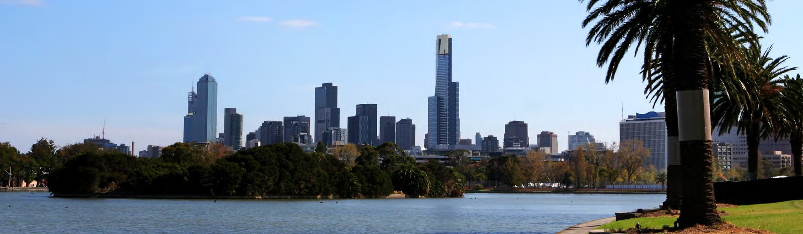

Les Clefs d’Or Australia presents the
2022 L E S CL E F S D’O R C O NCIE R GE TOUR ISM E XPO
Monday 30th May 2022 at Pullman Melbourne on the Park
192 Wellington Parade, East Melbourne VIC 3002

WHEN?
Monday 30th of May, 12:00pm sharp for registration.

WHAT TIME?
12:00pm: Delegate registration
12:30pm: Tourism Expo commencement (7.5 minute per exhibitor)
2:00pm: Refreshment Break (30min)
4:00pm: Canapes & Drinks
5:00pm: Tourism Expo Concludes

WHO CAN ATTEND?
Any hotel concierge or frontline hospitality professional providing tourism recommendations to Melbourne’s visitors - this includes porters or receptionists from any hotel accommodation category - everyone is welcome.

WHY ATTEND?
To establish new contacts and reinforce existing relationships with a wide range of tourism industry operators.
To expand and maintain your knowledge of Melbourne’s tourism products by meeting with Melbourne’s leading tourism suppliers in one afternoon.
To impress your guests with your broad knowledge of the latest information on
Melbourne tourism oﬀerings.
VENUE:
Pullman Melbourne on the Park, 192 Wellington Parade, East Melbourne VIC 3002.

WHAT TO BRING:
Business Cards if you have them (not essential)

DRESS CODE:
Business attire (preferred) but business casual or hotel uniforms are ﬁne.

TRANSPORT:
Tram 75 – from Flinders Street or Tram 48 from Collins Street

ACTION REQUIRED:
Acquire your ticket on Humanitix by Sunday 15th of May 2022:
https://events.humanitix.com/les-clefs-d-or-tourism-expo

QUESTIONS:
Contact Matthew Du, statedirector.vic@lesclefsdoraustralia.org

